SEMESTER TWO
Papers written by
Australian Maths
Software

YEAR 12, Unit 3-4

MATHEMATICS APPLICATIONS
REVISION 1
2016

Section One
(Calculator–free)

Name: _________________________________

Teacher: ________________________________

TIME ALLOWED FOR THIS SECTION

Reading time before commencing work: 5 minutes
Working time for section: 50 minutes

MATERIAL REQUIRED / RECOMMENDED FOR THIS SECTION

To be provided by the candidate
Standard items: pens, pencils, pencil sharpener, highlighter, eraser, ruler.

IMPORTANT NOTE TO CANDIDATES
No other items may be taken into the examination room. It is your responsibility to ensure
that you do not have any unauthorised notes or other items of a non–personal nature in the
examination room. If you have any unauthorised material with you, hand it to the supervisor
before reading any further.

To be provided by the supervisor

Question/answer booklet for Section One.
A formula sheet which may also be used for Section Two.
Structure of this examination

 | Number of questions available | Number of questions to be answered | Working time (minutes) | Marks available | Percentage of exam
Section One  Calculator—free | 7 | 7 | 50 | 50 | 35
Section Two  Calculator—assumed | 8 | 8 | 100 | 100 | 65
Total marks |  |  |  | 150

Instructions to candidates

1. The rules for the conduct of this examination are detailed in the Information
Handbook. Sitting this examination implies that you agree to abide by these rules.

2. Write your answers in the Question/Answer booklet.

3. You must be careful to confine your responses to the specific questions asked and to
follow any instructions that are specific to a particular question.

4. Spare pages are provided at the end of this booklet. If you need to use them, indicate
in the original answer space where the answer is continued i.e. give the page number.

5. Show all your working clearly. Your working should be in sufficient detail to allow your
answers to be checked readily and for marks to be awarded for reasoning. Incorrect
answers given without supporting reasoning cannot be allocated any marks. For any
question or part question worth more than two marks, valid working or justification is
required to receive full marks. If you repeat an answer to any question, ensure that you
cancel the answer you do not wish to have marked.

6. It is recommended that you do not use pencil, except in diagrams.

7. The Formula Sheet is not to be handed in with your Question/Answer booklet.

.1. (11 marks)

(a) Consider the following sequence 10, 14, 18, 22 ,….

(i) Find the expression for T_{n} in terms of n. (2)

(ii) Use your rule to determine T₁₀. (2)

(iii) Determine the value of n where T_{n} = 86. (2)

(iv) Define the sequence recursively. (2)

(b) Given 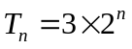
(i) Determine the first three terms (3)

(ii) Define the sequence recursively. (2)

2. (3 marks)
A linear fit is applied to a set of data.
The set of residuals is graphed on the set of axes below.
R
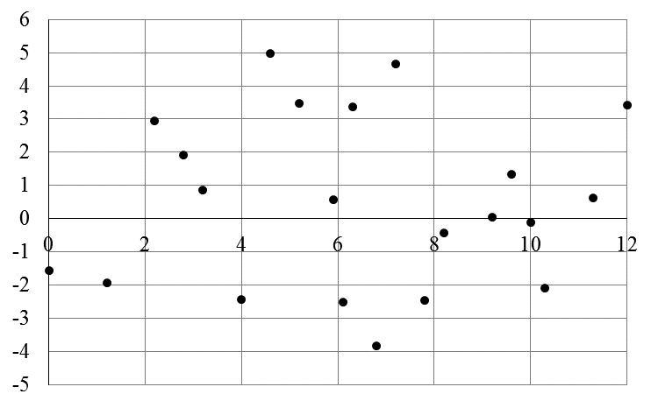
x
State with reasons, whether or not the linear fit was appropriate. (3)

3. (6 marks)
(a) The following diagram represents a tree. Write down what the tree could
represent. (2)

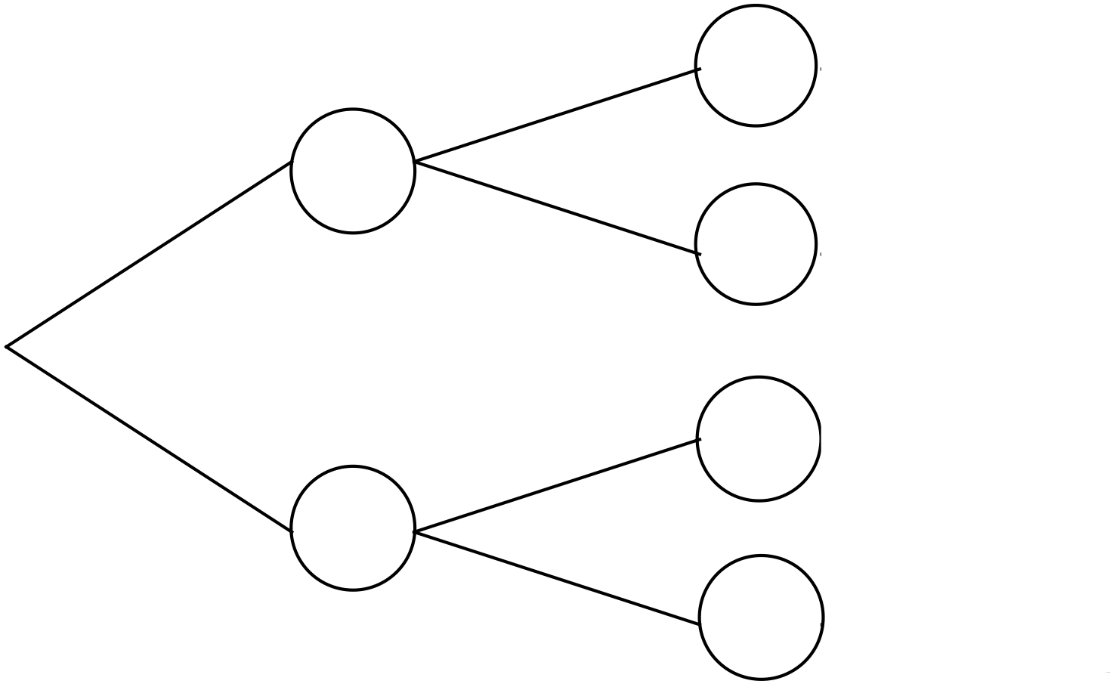

(b) Draw a tree diagram that has 8 nodes 7 arcs and one region. (2)

(c) Explain carefully why the following graph represents a bipartite graph. (2)
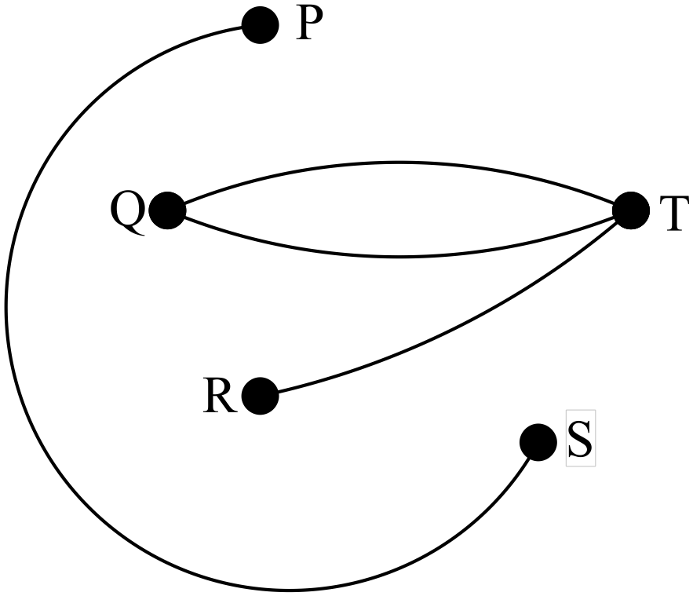
4. (13 marks)

Given the project network graphed below

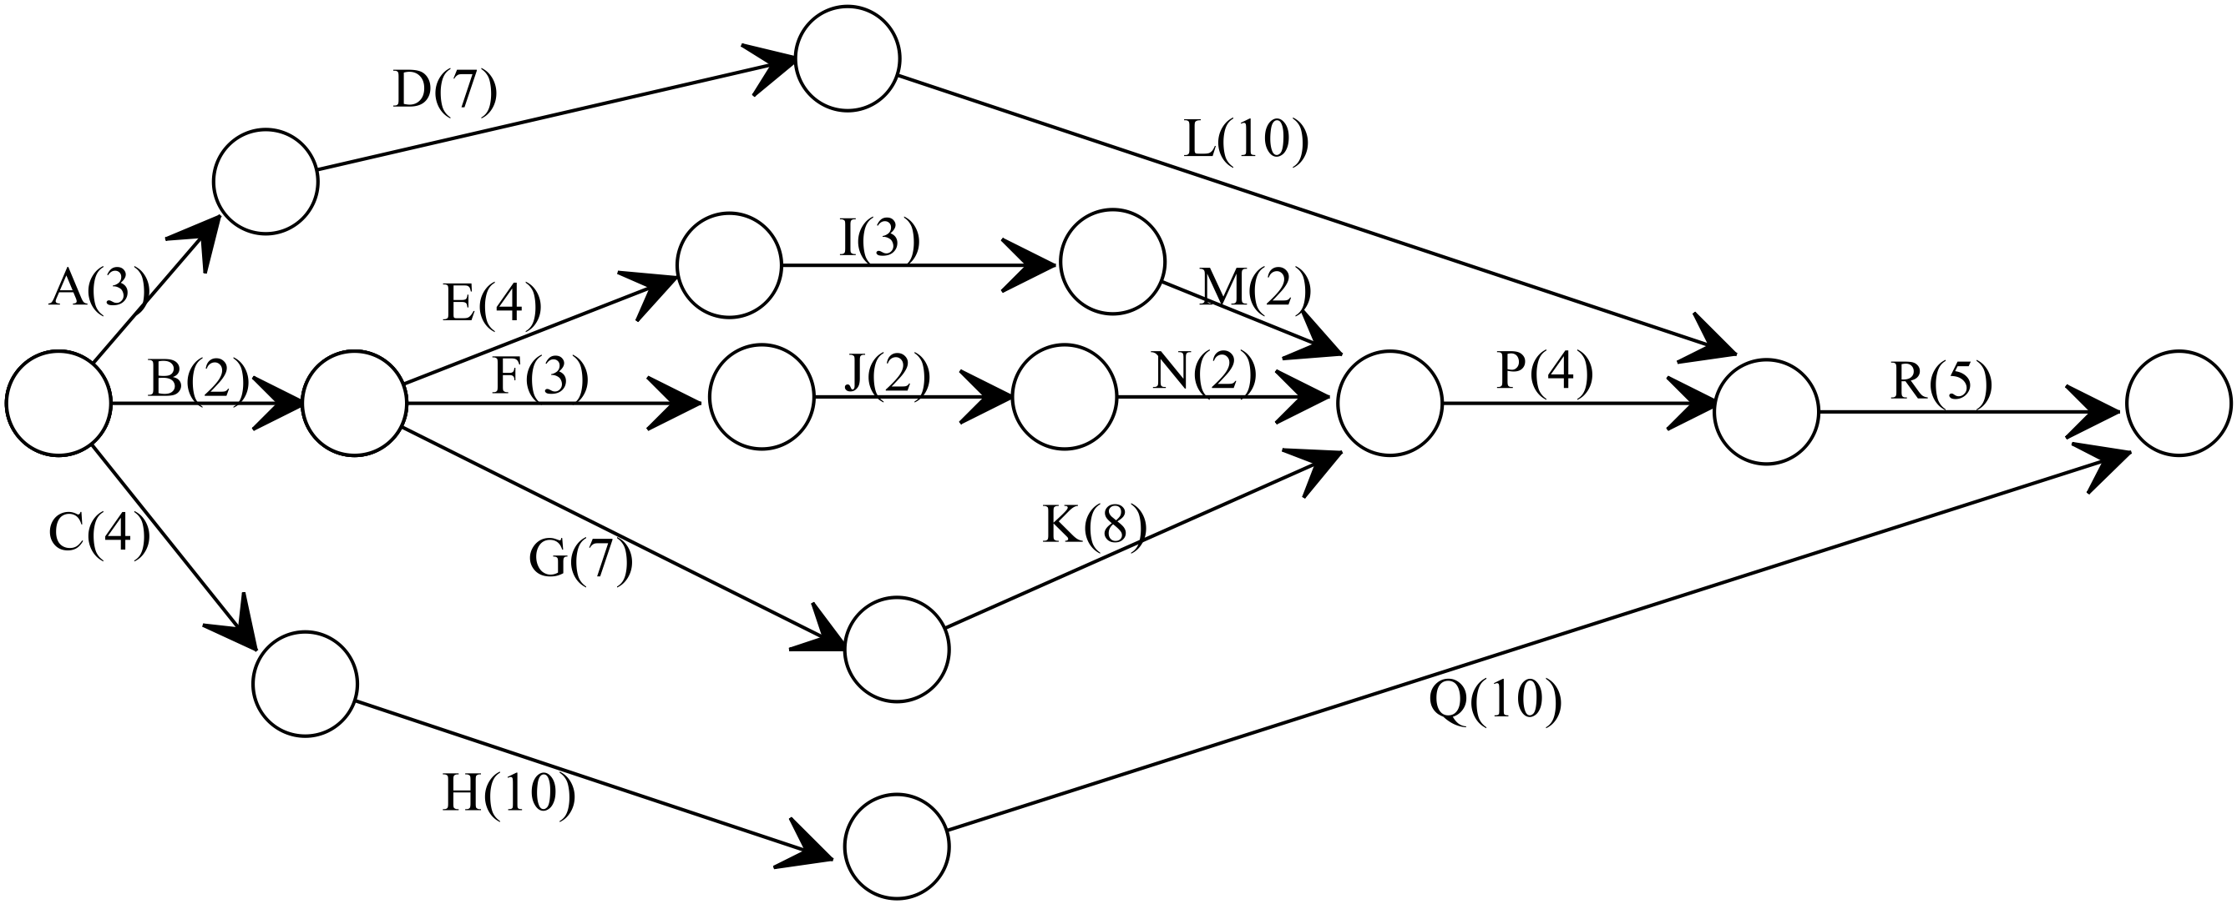
(a) Complete the table showing the tasks, the immediate predecessors and the
duration of each task. (5)
Task | Immediate Predecessors | Duration (minutes)
A
B
C
D
E
F
G
H
J
K
L
M
N
p

(b) Do a forward scan to determine the minimum completion time (3)

(b) List the critical path. (2)

(c) What is the maximum time Task A be delayed so that it does not change the
minimum completion time? (1)

(e) If task B is done immediately, how many minutes can E be delayed so as to not
necessarily change the critical path. (1)

(f) State the float time (slack time) for task Q. (1)

5. (7 marks)

Each of the points A, B, C, ….H need to be connected to the water main to have
a supply of water.
The cost of the connections depends on the length of the piping used.

All possible piping connections are shown on the diagram below with
measurements in metres.
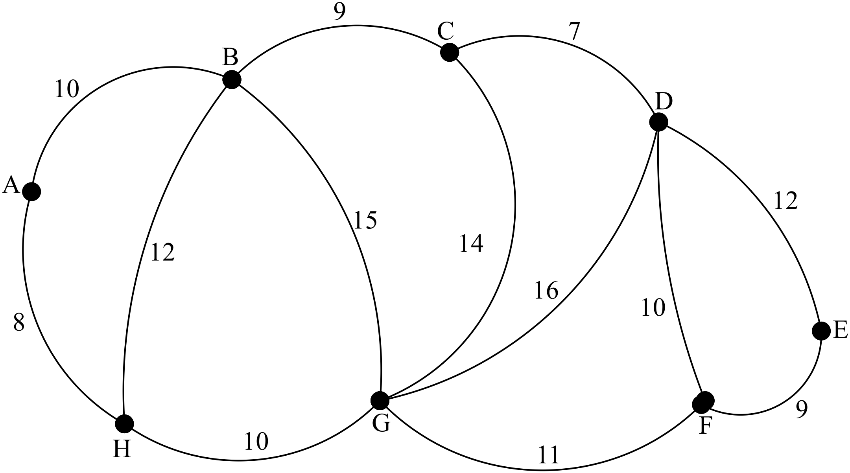

(a) Shade the minimum spanning tree on the diagram below so you can
minimise the length of piping used. (3)

(b) State the minimum length of pipng required for the installation of
power points in the factory. (2)

(c) If a connection cannot be made between A and B, what changes does this
cause to the minimum spanning tree? (2)

6. (5 marks)
Water is falling down a hillside in streamlets. The figures show the number of litres a minute the streamlets can handle without overflowing. Units are litres/minute.
(a). Do the streamlets overflow when 120 litres flows through the start in a minute? (4)

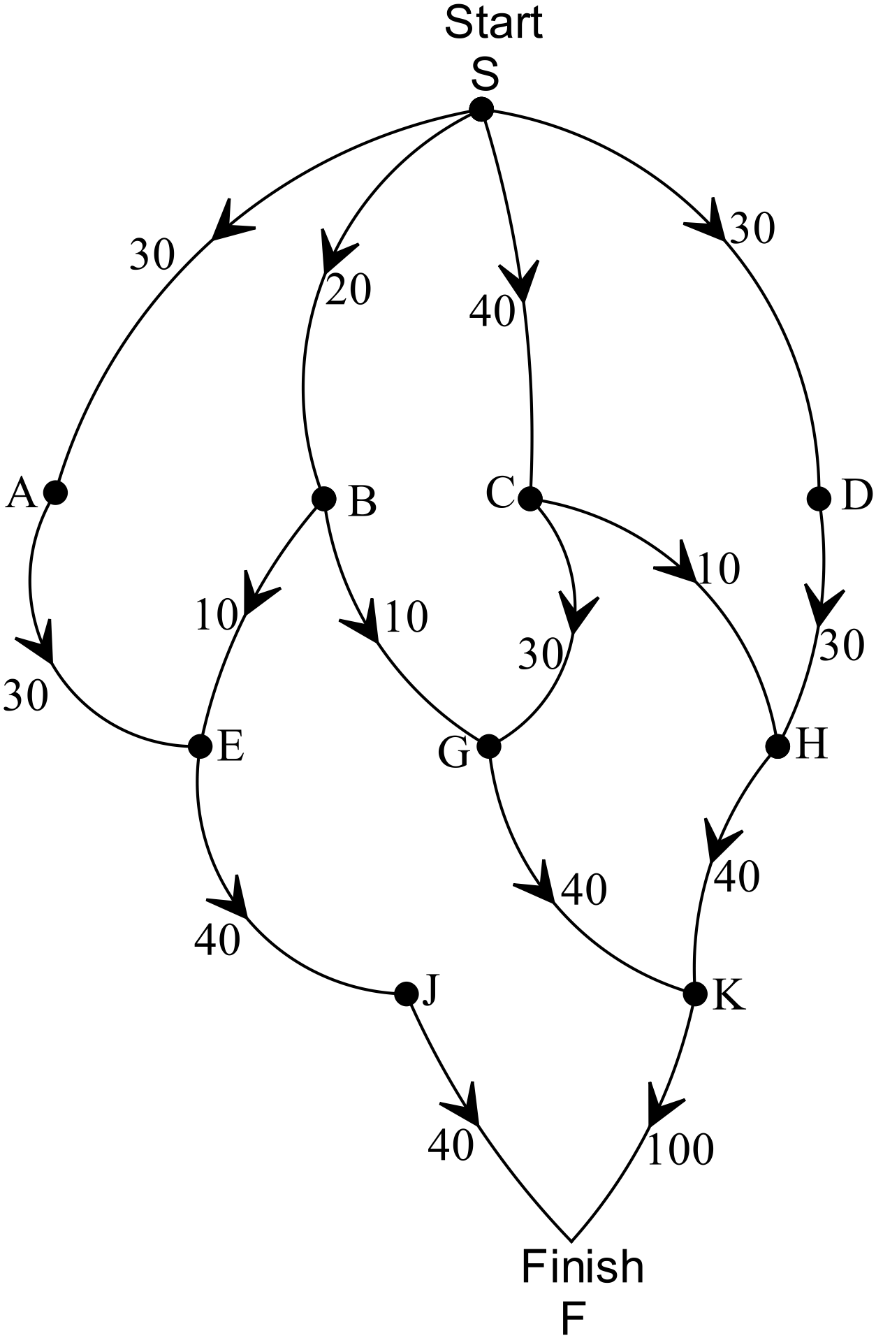

(b) Find the minimum cut and illustrate it on the diagram (1)

7. (5 marks)
A sequence is defined as 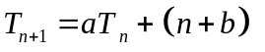with 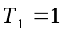.
The sequence is graphed below.
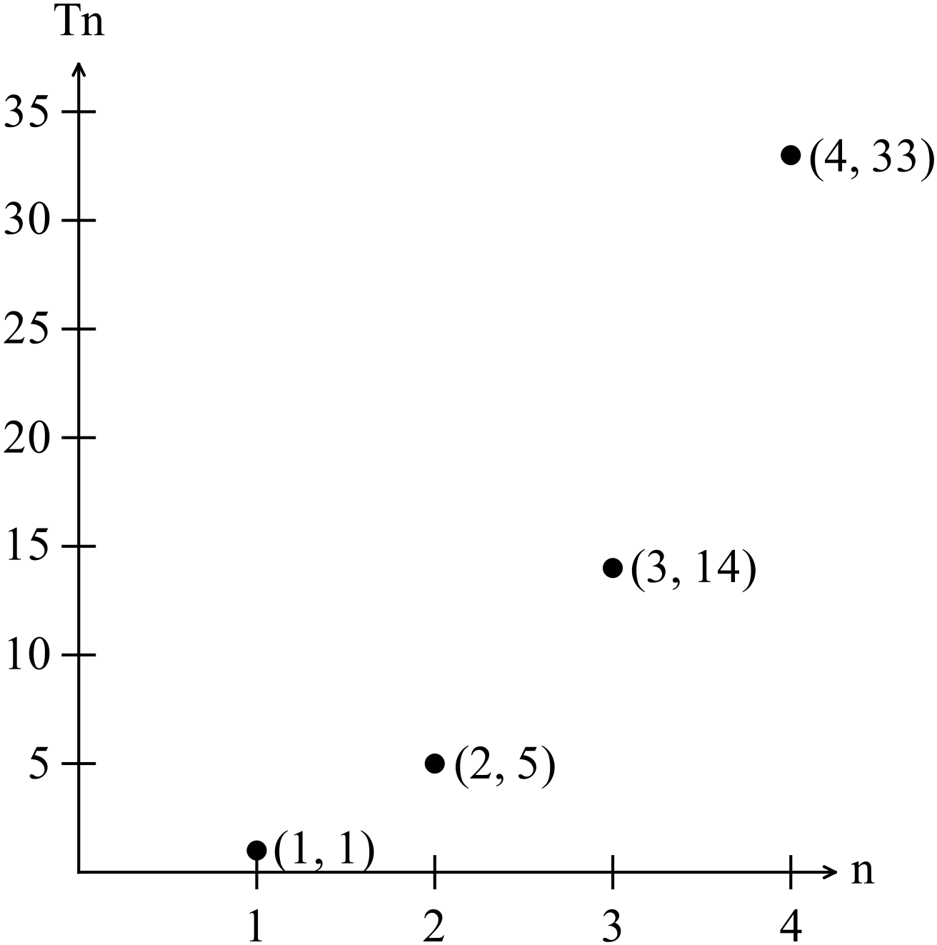
Find the values of 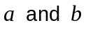. (5)

END OF SECTION ONE

